γ ratio of air

Heat and Thermodynamics
http://hyperphysics.phy-astr.gsu.edu/hbase/hframe.html
HyperPhysics
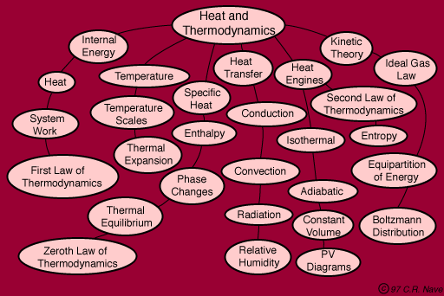

Ideal Gas Law
An ideal gas is defined as one in which all collisions between atoms or molecules are perfectly eleastic and in which there are no intermolecular attractive forces. One can visualize it as a collection of perfectly hard spheres which collide but which otherwise do not interact with each other. In such a gas, all the internal energy is in the form of kinetic energy and any change in internal energy is accompanied by a change in temperature.
An ideal gas can be characterized by three state variables: absolute pressure (P), volume (V), and absolute temperature (T). The relationship between them may be deduced from kinetic theory and is called the

- n = number of moles
- R = universal gas constant = 8.3145 J/mol K
- N = number of molecules
- k = Boltzmann constant = 1.38066 x 10⁻²³ J/K = 8.617385 x 10⁻⁵ eV/K
- k = R/N_{A}
- N_{A} = Avogadro's number = 6.0221 x 10²³ /mol
The ideal gas law can be viewed as arising from the kinetic pressure of gas molecules colliding with the walls of a container in accordance with Newton's laws. But there is also a statistical element in the determination of the average kinetic energy of those molecules. The temperature is taken to be proportional to this average kinetic energy; this invokes the idea of kinetic temperature. One mole of an ideal gas at STP occupies 22.4 liters.
Calculation
Departure from an ideal gas: van der Waals equation of state

Ideal Gas Law with Constraints
For the purpose of calculations, it is convenient to place the ideal gas law in the form:
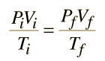
where the subscripts i and f refer to the initial and final states of some process. If the temperature is constrained to be constant, this becomes:
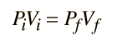

which is referred to as Boyle's Law.
If the pressure is constant, then the ideal gas law takes the form
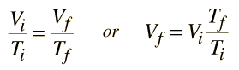

which has been historically called Charles' Law. It is appropriate for experiments performed in the presence of a constant atmospheric pressure.
All the possible states of an ideal gas can be represented by a PvT surface as illustrated below. The behavior when any one of the three state variables is held constant is also shown.
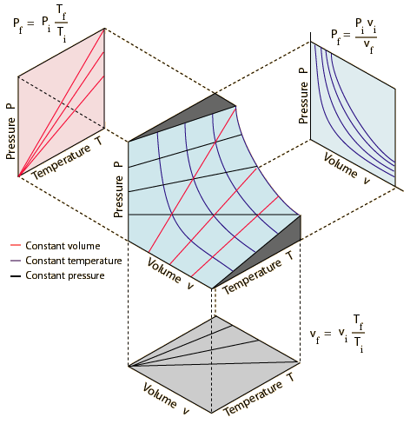

Specific Heat
The specific heat is the amount of heat per unit mass required to raise the temperature by one degree Celsius. The relationship between heat and temperature change is usually expressed in the form shown below where c is the specific heat. The relationship does not apply if a phase change is encountered, because the heat added or removed during a phase change does not change the temperature.
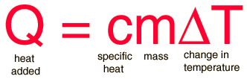

The specific heat of water is 1 calorie/gram °C = 4.186 joule/gram °C which is higher than any other common substance. As a result, water plays a very important role in temperature regulation. The specific heat per gram for water is much higher than that for a metal, as described in the water-metal example. For most purposes, it is more meaningful to compare the molar specific heats of substances.
The molar specific heats of most solids at room temperature and above are nearly constant, in agreement with the Law of Dulong and Petit. At lower temperatures the specific heats drop as quantum processes become significant. The low temperature behavior is described by the Einstein-Debye model of specific heat.
Table | Specific heats of gases |  | Specific heats of solids
Calculation

Constant Volume Process
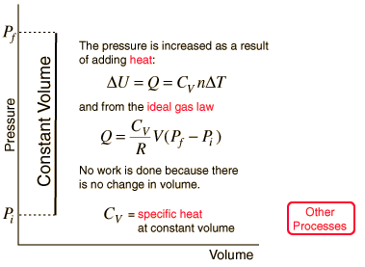

For a mass of gas consisting of n= moles at a pressure
= kPa = x10^ Pa,
(One atmosphere of pressure is about 101.3 kPa.)
volume |  | =

and specific heat |  | = J/mol K,
the increase in pressure to
= kPa = x10^ Pa,
requires input heat
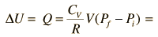 | = J = x10^ J
All of this heat contributes to the increase in the internal energy of the gas since no work is done. The initial and final temperatures can be calculated from the pressure and volumes using the ideal gas law:
= K

= K

Constant Pressure Specific Heat
The molar specific heat at constant pressure is defined by
Using the first law of thermodynamics for a constant pressure process this can be put in the form
From the ideal gas law (PV=nRT) under constant pressure conditions it can be seen that
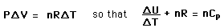
Since the constant volume specific heat is
it follows that
For an ideal monoatomic gas
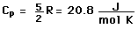

Specific heats and molar heat capacities for various substances at 20 C
Substance | c in J/gm K | c in cal/gm K or  Btu/lb F | Molar C  J/mol K
Aluminum | 0.900 | 0.215 | 24.3
Bismuth | 0.123 | 0.0294 | 25.7
Copper | 0.386 | 0.0923 | 24.5
Brass | 0.380 | 0.092 | ...
Gold | 0.126 | 0.0301 | 25.6
Lead | 0.128 | 0.0305 | 26.4
Silver | 0.233 | 0.0558 | 24.9
Tungsten | 0.134 | 0.0321 | 24.8
Zinc | 0.387 | 0.0925 | 25.2
Mercury | 0.140 | 0.033 | 28.3
Alcohol(ethyl) | 2.4 | 0.58 | 111
Water | 4.186 | 1.00 | 75.2
Ice (-10 C) | 2.05 | 0.49 | 36.9
Granite | .790 | 0.19 | ...
Glass | .84 | 0.20 | ...

Specific Heats of Gases
The specific heats of gases are generally expressed as molar specific heats. For a monoatomic ideal gas the internal energy is all in the form of kinetic energy, and kinetic theory provides the expression for that energy, related to the kinetic temperature. The expression for the internal energy is
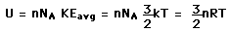

Two specific heats are defined for gases, one for constant volume (C_{V}) and one for constant pressure (C_{P}). For a constant volume process with a monoatomic ideal gas the first law of thermodynamics gives:
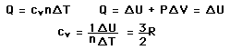 | More general case

Further application of the ideal gas law and first law gives the relationship
Show

The ratio of the specific heats  = C_{P}/C_{V} is a factor in adiabatic engine processes and in determining the speed of sound in a gas. This ratio  = 1.66 for an ideal monoatomic gas and  = 1.4 for air, which is predominantly a diatomic gas.

Constant Volume Specific Heat
The molar specific heat at constant volume is defined by

Using the first law of thermodynamics this can be put in the form

but since |  | = 0, the expression for C_{V} becomes

For a monoatomic ideal gas, |  | , so
This value agrees well with experiment for monoatomic noble gases such as helium and argon, but does not describe diatomic or polyatomic gases since their molecular rotations and vibrations contribute to the specific heat. The equipartition of energy predicts
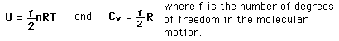

Constant Pressure Specific Heat
The molar specific heat at constant pressure is defined by
Using the first law of thermodynamics for a constant pressure process this can be put in the form
From the ideal gas law (PV=nRT) under constant pressure conditions it can be seen that
Since the constant volume specific heat is
it follows that
.
For an ideal monoatomic gas

Selected Specific Heats
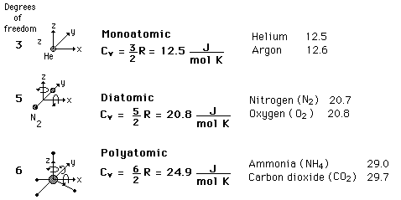
The models of constant-volume specific heat based on equipartition of energy and including rotational degrees of freedom as well as translational are able to explain specific heats for diatomic molecules. The departure from this model in the case of polyatomic molecules indicates vibrational involvement.
The constant pressure specific heat is related to the constant volume value by C_{P} = C_{V} + R. The ratio of the specific heats  = C_{P}/C_{V} is a factor in adiabatic engine processes and in determining the speed of sound in a gas.

Hydrogen as example of diatomic molecule

Hydrogen Specific Heat
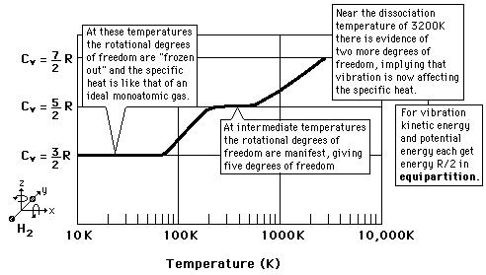
The behavior of the specific heat of hydrogen with changing temperature was extremely puzzling early in the 20th century. At low temperatures it behaved like a monoatomic gas, but at higher temperatures its specific heat took on a value similar to other diatomic molecules. It took the development of the quantum theory to show that diatomic hydrogen, with its tiny rotational inertia, required a large amount of energy to excite its first excited molecular rotation quantum state. Since it could not get that amount of energy at low temperatures, it acted like a monoatomic gas.
Specific heats of gases | Equipartition of energy

Equipartition of Energy
The theorem of equipartition of energy states that molecules in thermal equilibrium have the same average energy associated with each independent degree of freedom of their motion and that the energy is
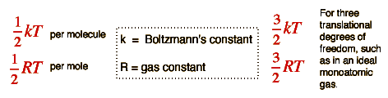
The equipartition result
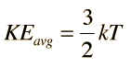
serves well in the definition of kinetic temperature since that involves just the translational degrees of freedom, but it fails to predict the specific heats of polyatomic gases because the increase in internal energy associated with heating such gases adds energy to rotational and perhaps vibrational degrees of freedom. Each vibrational mode will get kT/2 for kinetic energy and kT/2 for potential energy - equality of kinetic and potential energy is addressed in the virial theorem. Equipartition of energy also has implication for electromagnetic radiation when it is in equilibrium with matter, each mode of radiation having kT of energy in the Rayleigh-Jeans law.
For the translational degrees of freedom only, equipartition can be shown to follow from the Boltzmann distribution.
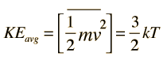
  Show

Average thermal energy | Define constants
Specific heats of solids | Specific heats of gases

